ML performance evaluation
Model Evaluation for two ML algorithms: Classification and Regression
- Model Evaluation Datasets:
Evaluation of model is done after mode is trained.
The data is partitioned into 3 sets: Training, Validation, and Testin Sets.
The ratio of partitioning can be: 80-10-10 or 75-15-15
Training set – used to train the model.
Validation and Testing set – used to evaluate the trained model performance.
Validation Set:
To begin evaluating how the model responds in a non-training env, start by looking at the data that was set asides as the validation set. The model should generalize to data it has not seen.
Testing Set:
After improving the model using validation data, the model is ready to be tested one last time to ensure its predictive quality meets our standards.

- Model Fit:
Model fit is important to understand the root cause of poor model accuracy. The predictive model is either underfitting or overfitting the training data can be determined by look at the prediction error on the training data and the evaluation data.
Overfitting:
The model performs well on training data but poorly in evaluation data. This is because the model has memorized the data it has seen and is unable to generalize to unseen examples.
It capturing all the features of data and noise also as feature of data.
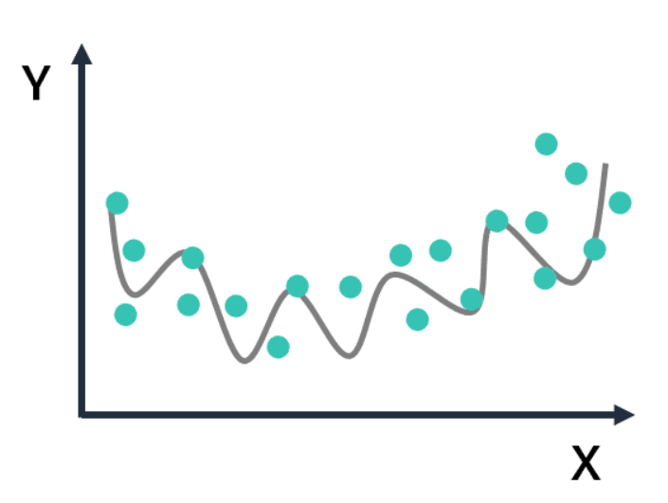
Underfitting:
The model is too simple and performs poorly on training data. This is because the model is unable to capture the relationship between the input examples and the target values.
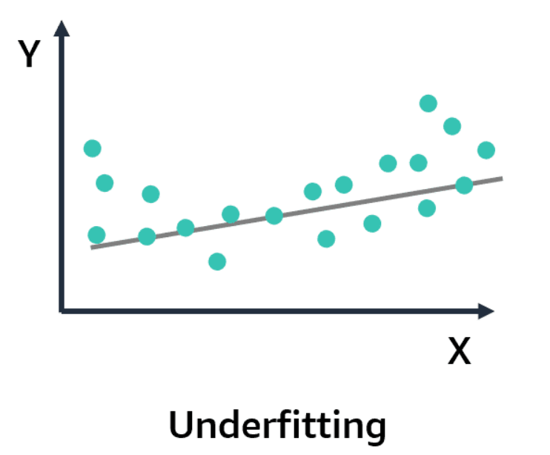

Balanced:
The model is balanced when it is not overfit or underfit on the training data.
It captures enough features which is necessary for the model to perform well on training as well as evaluation data.
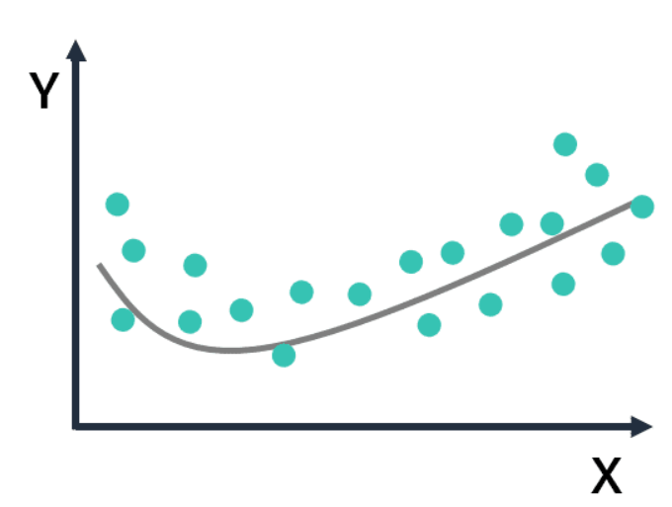

- Bias and Variance
Bias indicates the missing important features of the data sets by the model. It means the data is too basic. It is measured by the difference between the predicted value and the true value.
So, the model has high bias, that means the model is underfitting. Underfitted means the model is not capturing enough differences in the features of data, so the model performs poorly even in training data.
Variance refers to the model's sensitivity to fluctuations or noise in the training data. It basically means how dispersed the data are. So, the model might consider noise in the data to be important in the output. When the variance is high, the model becomes so familiar with the training data, it can make predictions with high accuracy because it is capturing all the features of the data.
When the new data is introduced, the accuracy drops because the new data can have different features that the model has not been trained on, which introduces overfitting. So, overfitting means model performs well on training data only. Model is memorizing the data it has seen and it is unable to generalize to unseen data.
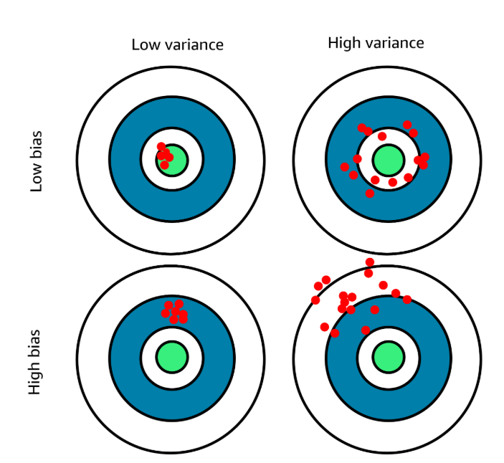
A bullseye is a nice analogy because, generally speaking, the center of the bullseye is where you aim your darts. The center of the bullseye in this situation is the label or target—it predicts the value of your model—and each dot is a result that your model produced during training.
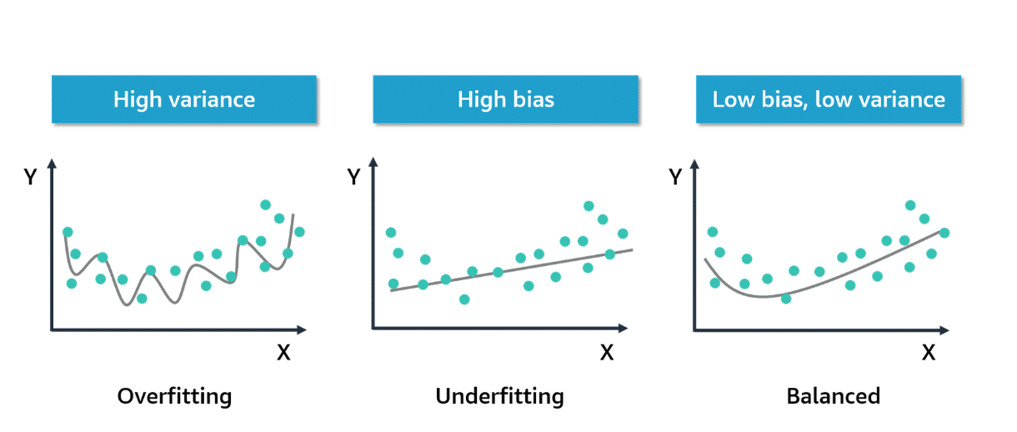
Classification and regression problems
Evaluation metrics for classification:
- Accuracy - Precision - Recall - F1-score - AUC-ROC
Evaluation metrics for regression:
- Mean Squared Error - R squared
Classification problem metrics
Classification example
The following is a binary classification problem where an image recognition model labels data as "cat" or "not cat."
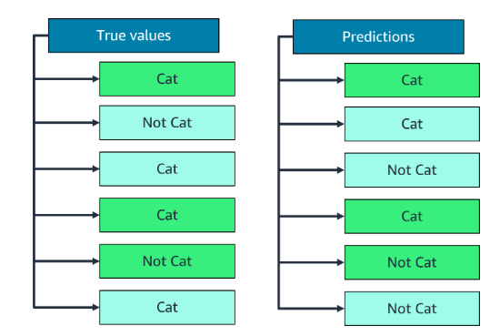
To evaluate a classification problem like the one shown, use the following steps:
Step 1: Send the held-out observations where you know the target values to the model.
Step 2: Compare the predictions returned by the model against the known target value.
Final Step: Compute a summary metric that shows how well the predicted and true values match.
- Confusion matrix
A confusion matrix can help classify why and how a model gets something wrong. It is the building block for running these types of model evaluations for classification problems. Review the following graphic, which is a confusion matrix for the image recognition example. The matrix gives a high-level comparison of how the predicted classes matched up against the actual classes.
After the model has been applied to the testing data, each of the four boxes in the matrix will include an aggregate number of the unique occurrences of true positives, false positives, false negatives, and true negatives.
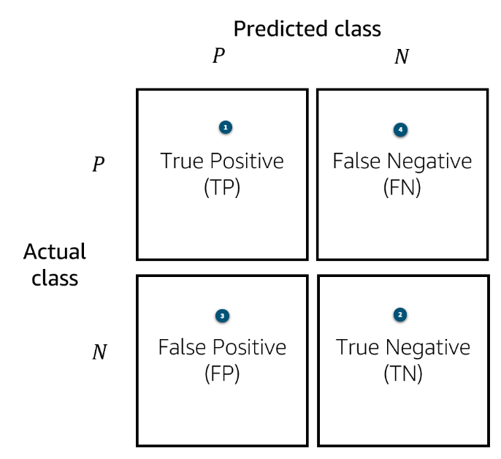
True positive (TP)
If the actual label or class is “cat,” which is identified as “P” for positive in the confusion matrix, and the predicted label or class is also “cat,” then you have a true positive result. This is a good outcome for your model.
True Negative (TN)
Similarly, if you have an actual label of “not cat,” which is identified as "N" for negative in the confusion matrix, and the predicted label or class is also “not cat,” then you have a true negative. This is also a good outcome for your model. In both cases, your model predicted the correct outcome when using the testing data.
False positive (FP)
This is less than ideal and is when the actual class is negative, so “not cat,” but the predicted class is positive, so “cat.” This is called a false positive because the prediction is positive but incorrect.
False negative (FN)
This is also less than ideal. A false negative occurs when the actual class is positive, so “cat,” but the predicted class is negative, so “not cat.”
- Accuracy
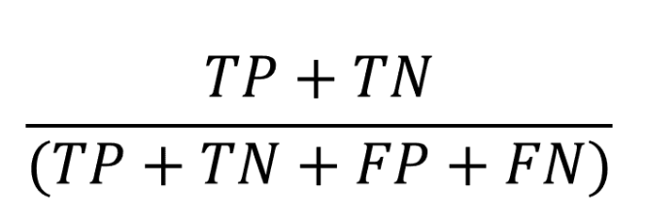
To calculate the model’s accuracy, also known as its score, add up the correct predictions and then divide that number by the total number of predictions.
Although accuracy is a widely used metric for classification problems, it has limitations. This metric is less effective when there are a lot of true negative cases in your dataset. This is why two other metrics are often used in these situations: precision and recall.
Also, accuracy can be misleading when the dataset has biased data.

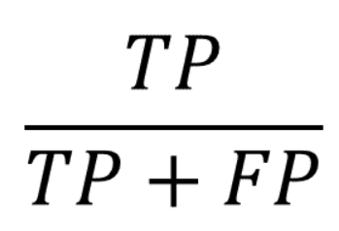
- Precision

Precision removes the negative predictions from the picture.
Precision is the proportion of positive predictions that are actually correct.
You can calculate it by taking the true positive count and dividing it by the total number of positives.
When the cost of false positives are high in your particular business situation, precision can be a good metric.
Think about a classification model that identifies emails as spam or not. In this case, you do not want your model labeling a legitimate email as spam and preventing your users from seeing that email.
- Recall
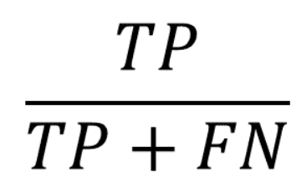
In addition to precision, there is also recall (or sensitivity).
In recall, you are looking at the proportion of correct sets that are identified as positive.
Recall is calculated by dividing the true positive count by the sum of the true positives and false negatives.
Think about a model that needs to predict whether a patient has a terminal illness or not. In this case, using precision as your evaluation metric does not account for the false negatives in your model. It is extremely important and vital to the success of the model that it not give false negative results. A false negative would be not identifying a patient as having a terminal illness when the patient actually does have a terminal illness. In this situation, recall is a better metric to use.

- AUC-ROC
Area under the curve-receiver operator curve (AUC-ROC) is another evaluation metric.
ROC is a probability curve, and AUC represents the degree or measure of separability.
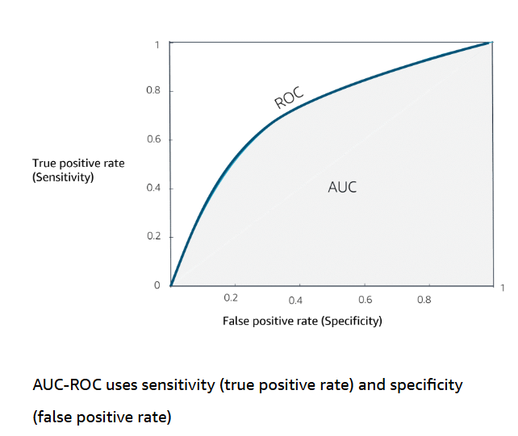
In general, AUC-ROC can show what the curve for true positive compared to false positive looks like at various thresholds. That means that when you calculate the AUC-ROC curve, you plot multiple confusion matrices at different thresholds and compare them to one another to find out the threshold you need for your business use case.
True Positive Rate (sensitivity) = TP/TP+FN
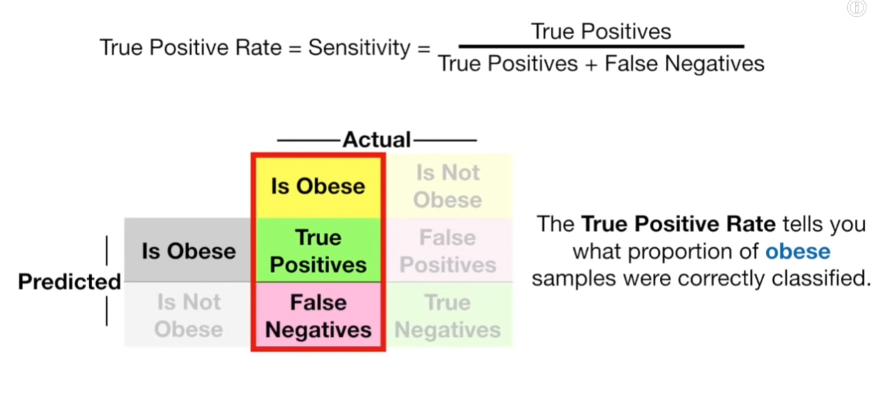

False Positive Rate (1-sensitivity) specificity = FP/FP+TN
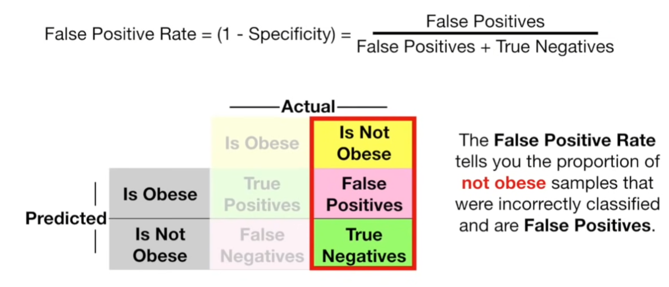

Regression problem metrics
Mean squared error
The general purpose of mean squared error (MSE) is to evaluate regression model performance by measuring prediction accuracy. You determine the prediction from the model and compare the difference between the prediction and the actual outcome.
More specifically, you take the difference between the prediction and actual value, square that difference, sum up all the squared differences for all the observations, and then divide by the total number of observations to get the average.
The smaller the MSE, the better the model's predictive accuracy.
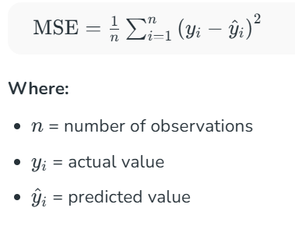
R squared
R squared is another commonly used metric with linear regression problems. R squared explains the fraction of variance accounted for by the model. It’s like a percentage, reporting a number from 0 to 1. When R squared is close to 1, it usually indicates that a lot of the variance in the data can be explained by the model itself.
MSE focuses on the average squared error of the model's predictions to provide a measure of model performance. R squared provides a measure of the model's goodness of fit to the data. Both are important but provide different perspectives.
